Task-1:
package demo;
import java.util.*;
import java.util.stream.*;
class Student {
String name;
int marks;
Student(String name, int marks) {
this.name = name;
this.marks = marks;
}
}

package demo;
import java.util.ArrayList;
import java.util.Comparator;
import java.util.List;
import java.util.Scanner;
import java.util.stream.Collectors;
public class Main {
public static void main(String[] args) {
Scanner sc = new Scanner(System.in);
int n = sc.nextInt();
List<Student> students = new ArrayList<>();
for (int i = 0; i < n; i++) {
String name = sc.next();
int marks = sc.nextInt();
students.add(new Student(name, marks));
}
int k = sc.nextInt();
List<String> topStudents = students.stream()
.sorted(Comparator
.comparingInt((Student s) -> s.marks).reversed()
.thenComparing(s -> s.name))
.limit(k)
.map(s -> s.name)
.collect(Collectors.toList());
System.out.println(String.join(" ", topStudents));
sc.close();
}
}
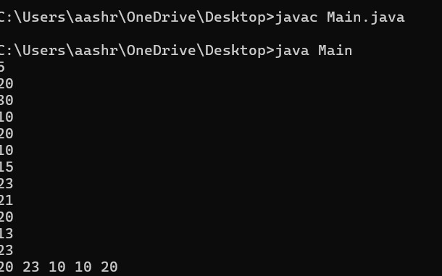

Task-2:
import java.util.Scanner;

public class Solution {
public static String getSmallestAndLargest(String s, int k) {
String smallest = s.substring(0, k);
String largest = s.substring(0, k);
// Loop through all substrings of length k
for (int i = 1; i <= s.length() - k; i++) {
String sub = s.substring(i, i + k);
if (sub.compareTo(smallest) < 0) {
smallest = sub;
}
if (sub.compareTo(largest) > 0) {
largest = sub;
}
}
return smallest + "\n" + largest;
}
public static void main(String[] args) {
Scanner scan = new Scanner(System.in);
String s = scan.next();
int k = scan.nextInt();
scan.close();

System.out.println(getSmallestAndLargest(s, k));
}
}
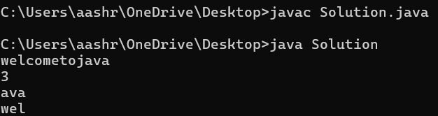
Task-3:
import java.util.*;
// Write your Checker class here
class Checker implements Comparator<Player> {
@Override
public int compare(Player a, Player b) {
// Sort by score descending
if (a.score != b.score) {
return b.score - a.score;
}
// If scores are same, sort by name ascending
return a.name.compareTo(b.name);
}
}
class Player{
String name;
int score;
Player(String name, int score){
this.name = name;
this.score = score;
}
}
class Solution {
public static void main(String[] args) {
Scanner scan = new Scanner(System.in);
int n = scan.nextInt();
Player[] player = new Player[n];
Checker checker = new Checker();
for(int i = 0; i < n; i++){
player[i] = new Player(scan.next(), scan.nextInt());
}
scan.close();

Arrays.sort(player, checker);
for(int i = 0; i < player.length; i++){
System.out.printf("%s %s\n", player[i].name, player[i].score);
}
}
}
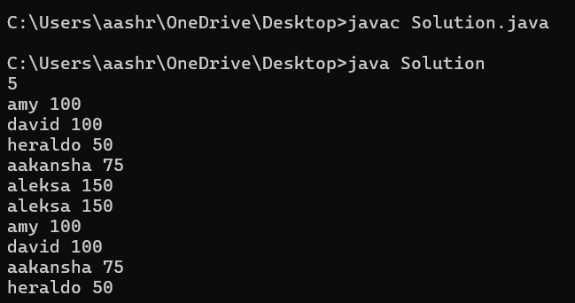
Task-4:
import java.util.*;
class Student{
private int id;
private String fname;
private double cgpa;
public Student(int id, String fname, double cgpa) {
super();
this.id = id;
this.fname = fname;
this.cgpa = cgpa;
}
public int getId() {
return id;
}
public String getFname() {
return fname;
}
public double getCgpa() {
return cgpa;
}
}
public class Solution
{
public static void main(String[] args){
Scanner in = new Scanner(System.in);
int testCases = Integer.parseInt(in.nextLine());
List<Student> studentList = new ArrayList<Student>();
while(testCases>0){
int id = in.nextInt();
String fname = in.next();
double cgpa = in.nextDouble();
Student st = new Student(id, fname, cgpa);
studentList.add(st);
testCases--;
}
Collections.sort(
studentList,
Comparator.comparing(Student::getCgpa).reversed()
.thenComparing(Student::getFname)
.thenComparing(Student::getId)
);
for(Student st: studentList){
System.out.println(st.getFname());
}
}
}
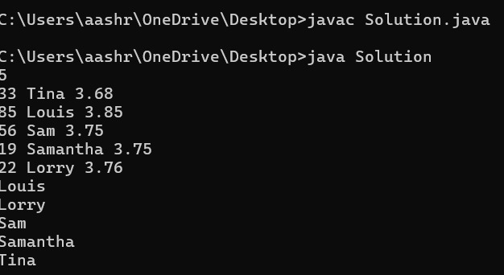
Task-5:
import java.io.*;
import java.util.*;
import java.math.BigDecimal;
class UserMainCode
{
public String addNumberStrings(String input1,String input2)
{
BigDecimal x = new BigDecimal(input1);
BigDecimal y = new BigDecimal(input2);
return String.valueOf(x.add(y));
}
}
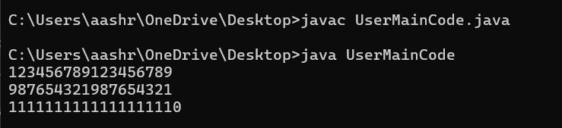
Task-6:
class Solution {
public String[] sortPeople(String[] names, int[] heights) {
int n = names.length;
Integer[] idx = new Integer[n];
for (int i = 0; i < n; i++) {
idx[i] = i;
}
Arrays.sort(idx, (a, b) -> heights[b] - heights[a]);

String[] result = new String[n];
for (int i = 0; i < n; i++) {
result[i] = names[idx[i]];
}
return result;
}
}
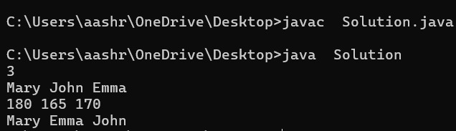
Task-7:
public class UserMainCode {
public static int NthPrime(int input1) {
int count = 0; // how many primes found
int number = 2; // candidate number to test

while (true) {
if (isPrime(number)) {
count++;
if (count == input1) {
return number; // found nth prime
}
}
number++;
}
}
// helper to check if num is prime
public static boolean isPrime(int num) {
if (num <= 1) return false;
if (num == 2) return true;
if (num % 2 == 0) return false;
for (int i = 3; i * i <= num; i += 2) {
if (num % i == 0) return false;
}
return true;
}
}
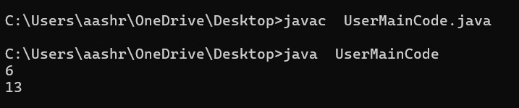
Task-8:
class UserMainCode
{
public int SeriesN(int input1,int input2,int input3,int input4){
int gap1 = (input2 - input1);
int gap2 = (input3 - input2);
int output = input1;
for (int i = 1; i < input4; i++) {
if (i % 2 == 1)
output += gap1;
else
output += gap2;
}
return output;
}
}
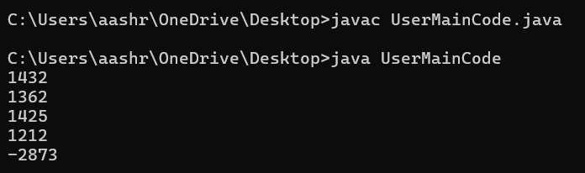
Task-9:
import java.io.*;
import java.util.*;

class UserMainCode {
public int getCodeThroughStrings(String input1){
String[] words = input1.split(" ");
int pin = 0;

for(String word : words) {
pin += word.length();
}
if (String.valueOf(pin).length() == 1) return pin;

int pin2 = 0;
String pinStr = String.valueOf(pin);
for (int i = 0; i < pinStr.length(); i++) {
pin2 += Integer.parseInt(String.valueOf(pinStr.charAt(i)));
}

return pin2;
}
}
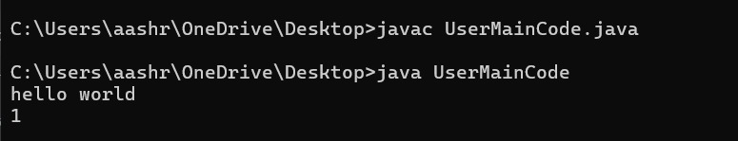

Task-10:
public class UserMainCode {
public int AddSub(int input1,int input2){
int result = input1;
int check = 0;

if (input2 == 1) check = 1;

for (int i = input1 - 1, j = 0; i >= 1; i--, j++) {
if (j % 2 == check) result += i;
else result -= i;
}
return result;
}
}
